1.

a.



b.

in-order,

10 15 20 25 30 39 40 50 60 65 70 71 80

pre-order,

50 20 10 15 40 30 25 39 60 70 65 80 71

post-order

15 10 25 39 30 40 20 65 71 80 70 60 50

c.



2.

struct BSTnode

{

Int m_value;

BSTnode* parent;

BSTnode* leftchild ;

BSTnode* rightchild;

}

insert()::

while starting from the root in the tree

{

if the value is the same

return;

if the value is greater than root value

go to the right child and insert from that node if possible

else

allocate new BSTnode

store the value

point the parent pointer to current root node

point the current root node right child to the node created

done and return

if the value is less than root value

go to the left child and insert from that node if possible

else

allocate new BSTnode

store the value

point the parent pointer to current root node

point the current root node left child to the node created

done and return

}

3.

3a.

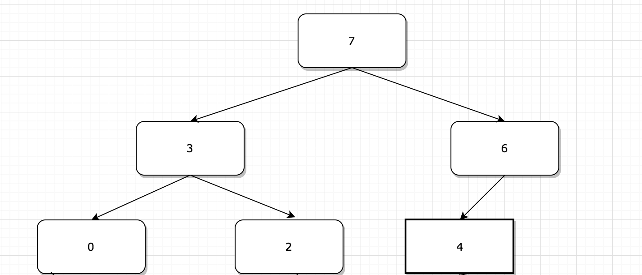

3b.

|  |  |  |  |  |  |
| --- | --- | --- | --- | --- | --- |
| 7 | 3 | 6 | 0 | 2 | 4 |

3c.

|  |  |  |  |  |
| --- | --- | --- | --- | --- |
| 6 | 3 | 4 | 0 | 2 |

4a. O(C + S)

4b. O(logC+S)

4c. O(logC + logS)

4d O(log(S))

4e. O(1)

4f. O(logC +S)

4g. O(S)

4h. O(Clog(S))